# Scenario 1: View Organizational Requirements

## Scenario Description

* View upcoming requirements needed for the organization based on a requested date

## Version Control

|  |  |  |  |
| --- | --- | --- | --- |
| Version # | Date | Author | Description |
| 1.0 | 25/08/2019 | Aaron Brody | Initial Version |

## Test Scripts

The following scripts will cover this scenario:

* 1.1 Default organizational requirements view
* 1.2 Custom scoping and viewing requirements
* 1.3 Resource is able to be allocated through this view

## Use Case

* View Organizational requirements

## Test Components/Requirements

This test scenario covers the following high-level test requirements (see scripts below for specific requirements covered by each test script):

* Any project containing an unassigned resource for the selected period will be displayed.
* Allow the company to view unfulfilled requirements easily

## User Groups

* Project Manager
* Resource

## Script 1.1: Default organizational requirements view

### Script Description

* A Project Manager is able to identify which project requirements have not been fulfilled and allocate a resource if required.

### Testing Requirements

This test script covers the following specific testing requirements:

* The default view contains projects with requirements that are not fulfilled only for the next month.

### Setup

* A project named “Next month” must exist with an unfulfilled requirement during the next month 15/06 to 15/07

### Teardown

* Delete the “Next Month” project

### Script Steps

| **Step #** | **Test Action** | **Expected Results** | **Pass/ Fail** |
| --- | --- | --- | --- |
| 1 | Click “View Projects” Button on the navigation bar | Opens View Projects Page, loads containing the Next Month project |  |
| 2 | Take screenshot and add results below test execution area |  |  |

### Test Execution

|  |  |  |  |  |
| --- | --- | --- | --- | --- |
| Date/Time | Tester | Test ID | Test Phase | Status |
| 09/09/2019 | Aaron | 005 | IOCM | Successful |

Add screenshot here:

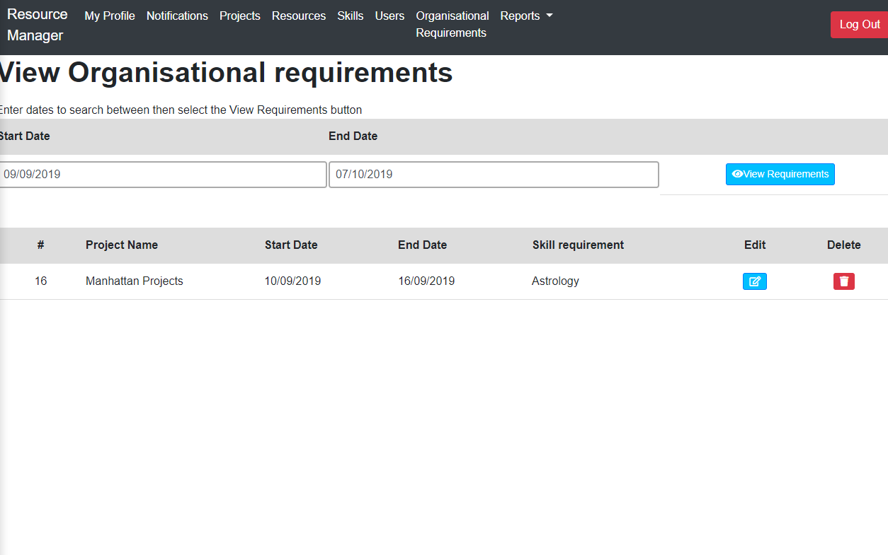

## Script 1.2: Custom scoping and viewing requirements

### Script Description

* A Project Manager is able to alter the search requirements and see the requirements for a specified period

### Testing Requirements

This test script covers the following specific testing requirements:

* Allow a project manager to see the types of resources that will be needed for a specified time period

### Setup

* “test project Extended Timeframe” must be created with a resource requirement between 01/Nov/2021 and 30/Nov/2021

### Teardown

* N/A

### Script Steps

| **Step #** | **Test Action** | **Expected Results** | **Pass/ Fail** |
| --- | --- | --- | --- |
| 1 | Click “View Projects” Button on the navigation bar | Opens View Projects Page, loads containing the Next Month project |  |
| 2 | Updates Start and end date dialogue to encompass 1/Nov/2021 to 30/Nov/2021, then click the View Requirements button | The results should update to include the “Test Project Extended Timeframe” project |  |
| 3 | Take screenshot and add results below test execution area | Screenshot exists |  |

### Test Execution

|  |  |  |  |  |
| --- | --- | --- | --- | --- |
| Date/Time | Tester | Test ID | Test Phase | Status |
| 09/09/02019 | Aaron | 0006 | IOCM | Successful |

Add screenshot here:

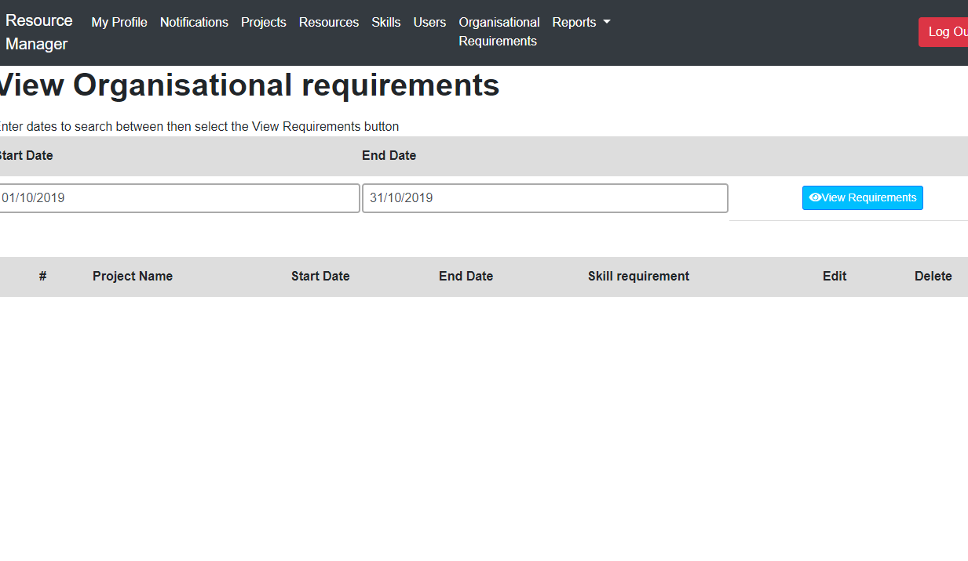

## Script 1.3: No Resource available during the timeframe specified

### Script Description

* A Project Manager is able to locate a resource for the skill requirement as required

### Testing Requirements

This test script covers the following specific testing requirements:

* Ensure that resources can be located to meet a skill requirement from the view organizational requirements page

### Setup

* “test project Extended Timeframe” must be created with a resource requirement in Java between 01/Nov/2021 and 30/Nov/2021 for 20 hours
* “Test Resource Java” should be created with Java and at least 20 hours available and have no allocation for November 2021

### Teardown

* N/A

### Script Steps

| **Step #** | **Test Action** | **Expected Results** | **Pass/ Fail** |
| --- | --- | --- | --- |
| 1 | Click “View Projects” Button on the navigation bar | Opens View Projects Page, loads containing the Next Month project | PASS |
| 2 | Updates Start and end date dialogue to encompass 1/Nov/2021 to 30/Nov/2021, then click the search button | The results should update to include the “Test Project Extended Timeframe” project | PASS |
| 3 | Click the Allocate Icon on the skill requirement | Open the Resource Search window  Test Resource Java Should be selectable | PASS |
| 4 | Check the test Resource Java resource then select “ok” | Test Resource Java is saved to skill requirement | PASS |
| 5 | Take screenshot and add results below test execution area | Screenshot exists | PASS |

### Test Execution

|  |  |  |  |  |
| --- | --- | --- | --- | --- |
| Date/Time | Tester | Test ID | Test Phase | Status |
| 09/09/02019 | Aaron | 00007 | IOCM | Successful |

Add screenshot here:

